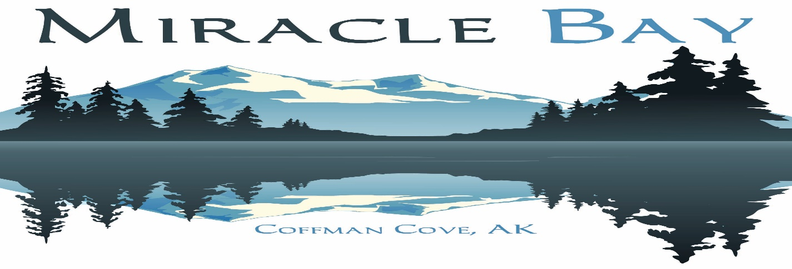
WORLDCLASS FISHING
Freshwater – Excellent Fly Fishing & Spin Cast Fishing
Salmon-Coho, Sockeye, Chum, and Pinks
Steelhead, Dolly Varden, Cutthroat
Saltwater Fishing – Protected Waters & Excellent Fishing
Salmon – Kings, Coho & Pinks
Halibut, Cod, Rockfish and Crab
(All fishing is self-guided)

Self-Guided Hunting Eco Tours & Wildlife Viewing
Trophy Black Bear – Spring or Fall Hunts Eagles, Bears, Whales, Seals, Sea Lions
Sitka Black tail Deer, Waterfowl Cave Tours, Hiking, Canoeing, Berry Picking

ACCOMODATIONS:
Guests will enjoy rustic cedar sided 2-bedroom, 2 bath cabins. Meals are served family style in our main lodge dining room with a beautiful view of the ocean. Miracle Bay is located on a 300-acre island accessible by a five-minute boat ride from the marina at Coffman Cove, Alaska.

HOW TO GET TO MIRACLE BAY:
Our guests can fly commercially into Ketchikan International airport and then fly by float plane or Island Air Express to Prince of Wales Island. Some might prefer to come by ferry from Ketchikan to Hollis. However, you get to Prince of Wales, our staff will be happy to pick you up and take you to Miracle Bay.

MISCELLANEOUS FEE SCHEDULE: Daily Boat & Vehicle Rentals Available

We can also arrange for rental of larger boats to go on the salt water for halibut and kings; Charters are also available. Cost will be negotiated on a first come first served and availability.
***Our package rates do not include transportation costs to and from Prince of Wales Island, hunting & fishing licenses, boat or vehicle fuel or gratuities. ***

PAYMENT POLICIES FOR ALL PACKAGES:
A deposit is required when reservations are made prior to January 1st; the 50% of the remaining balance is due February 1st and payment in full is due by April 15th. A deposit of 50% is required at the time reservations are made, if done after January 1st; the remaining balance is due by April 15th. Due to the limited length of our season all deposits and payments are non-refundable. Payments may be applied to the next year if notice is given, and the trip re-booked prior to March 1st. If payment is made by credit card there will be a 3% administration fee.

Bill Von Lanken, Executive Director
bill@outdoorsnetwork.org
PO Box 4502
Missoula MT 59806
406-360-6018
1/29/2023

